**How to create custom PowerApps in Dynamics 365 for Sales and Marketing and Embed Canvas App into model driven app**

Model-driven app design is a component-focused approach to app development for Dynamics 365. In this topic, you simplify how to create an App for Sales and Marketing using the existing Sales Hub Solution.

We have three steps to proceed this exercise

* Step 1: Adding Sales and Marketing application in our environment.
* Step 2: Create new app using existing solution
* Step 3: Embed Canvas App in Dynamics 365 Model driven App

**Step 1: Adding Sales and Marketing application in our environment.**

1. Go To <https://trials.dynamics.com/> (we are using trial module for our session)

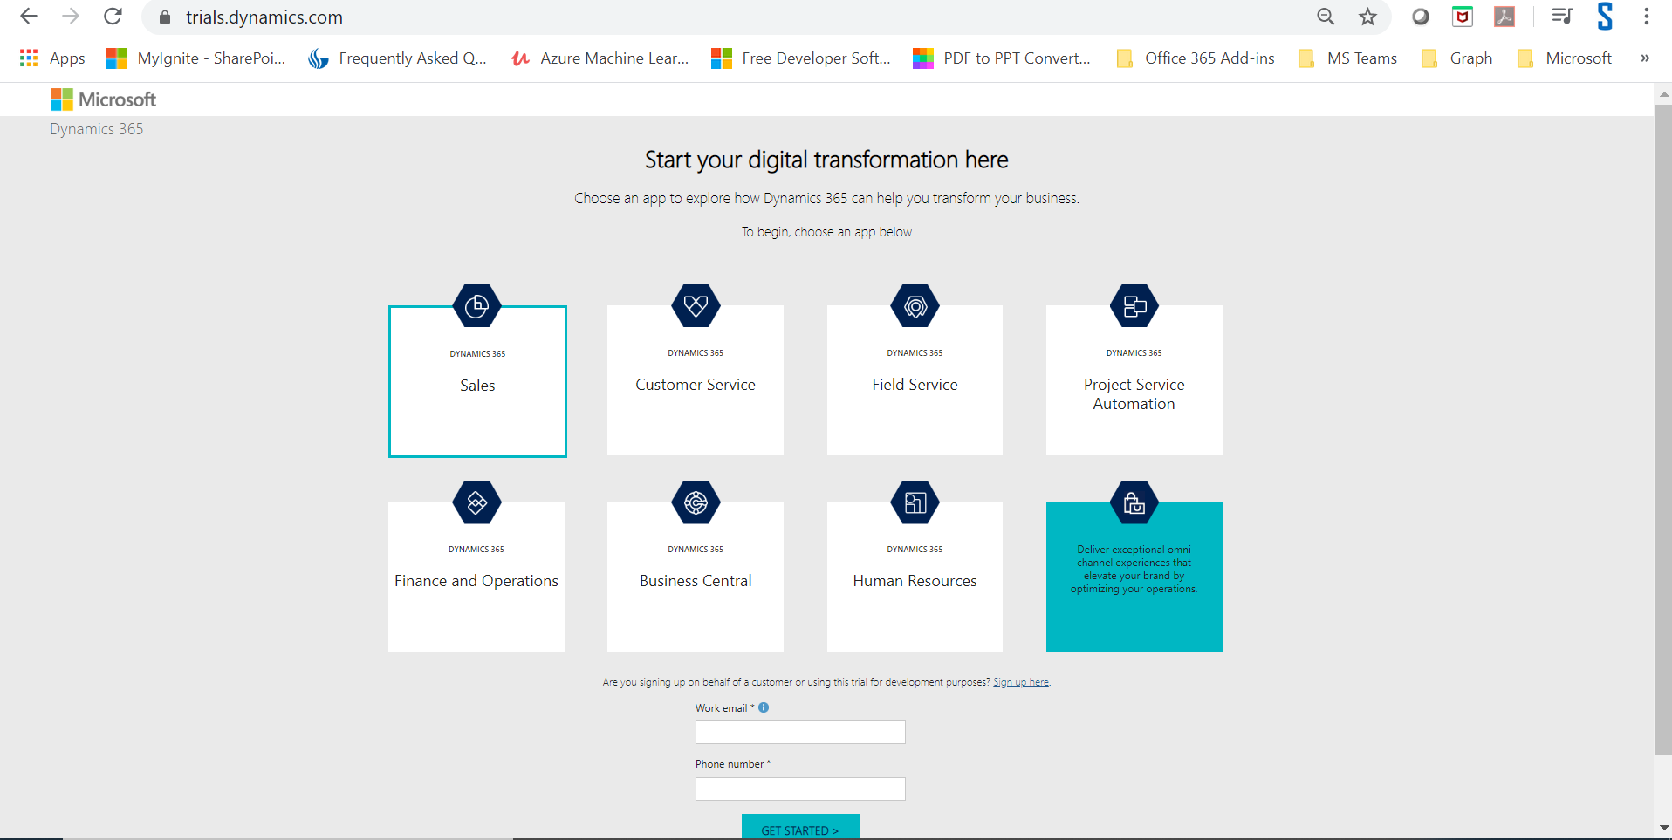

1. Select Sales

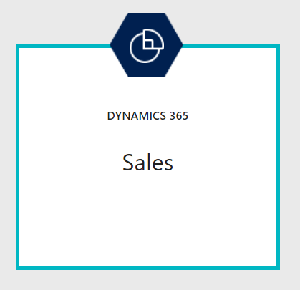

1. Enter Work Email, i.e. same email we created for office 365 developer subscription
2. Enter 10-digit Phone number

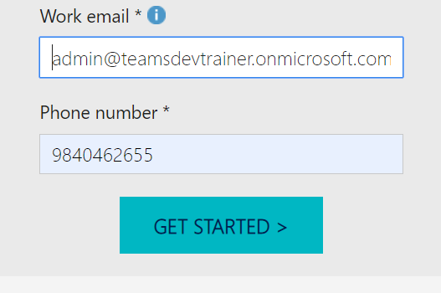

1. Click Get Started button, it will redirect to new window

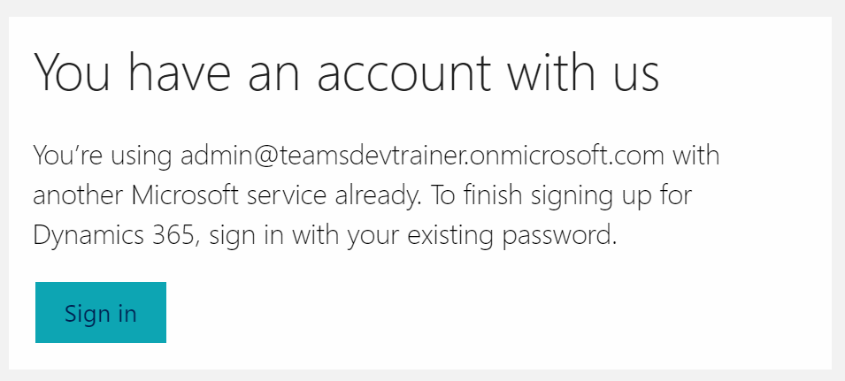

1. Sign In and continue
2. It will open the dynamics 365 environment area

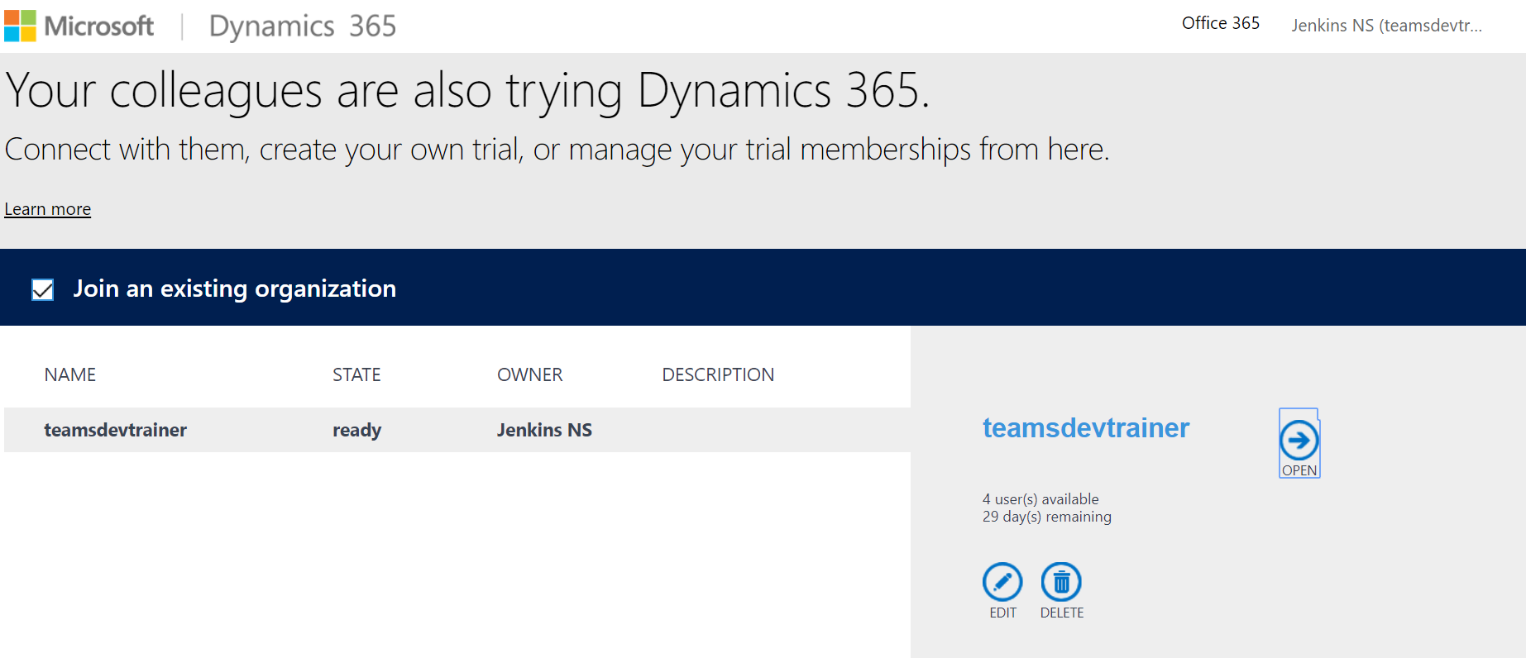

1. Click Open and see all our sales components

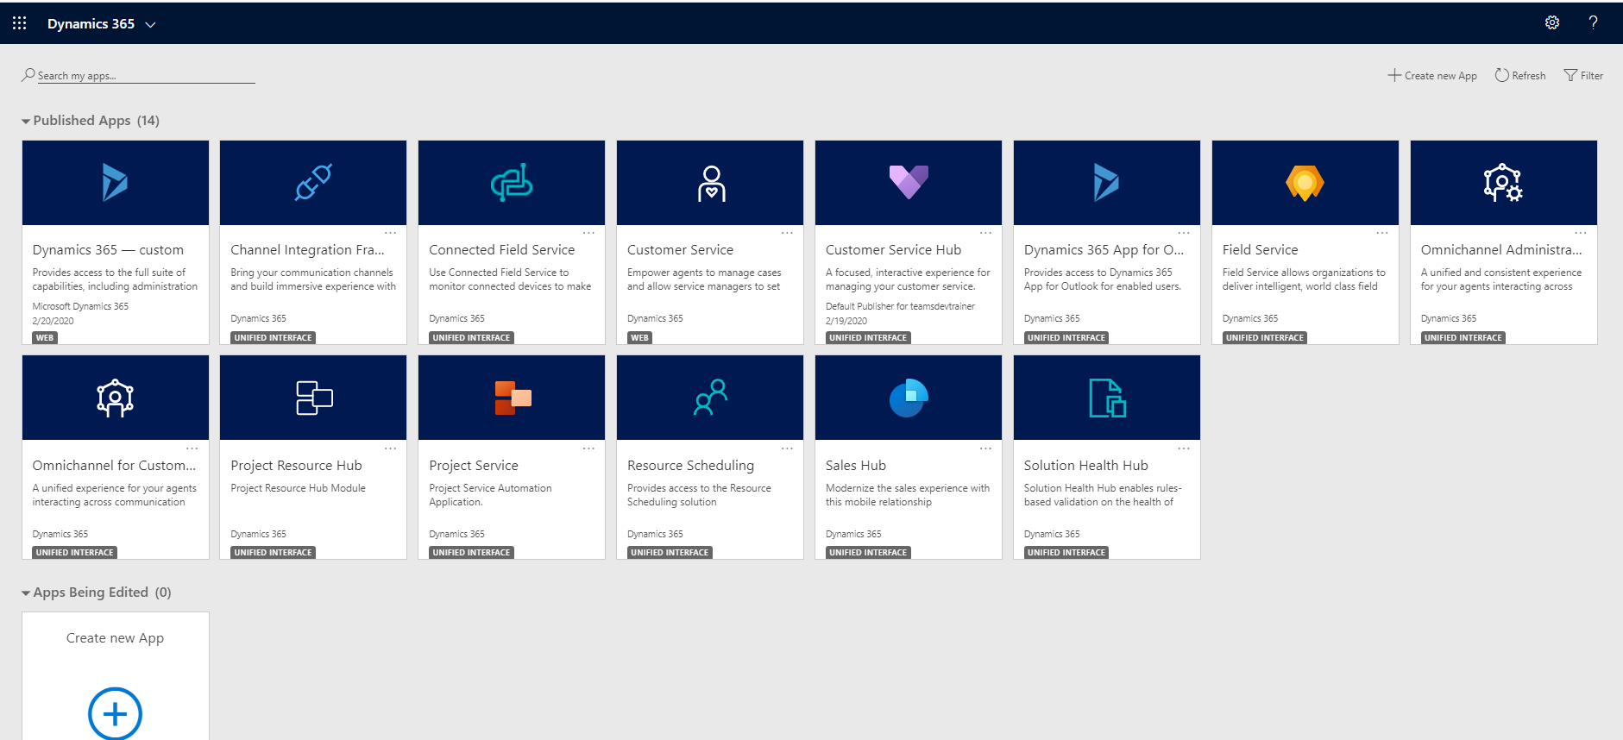

1. Now we are fine with create a custom Sales and Marketing app using Power Apps

**Step 2: Create new app using existing solution**

1. Click create new app link in the right-hand side

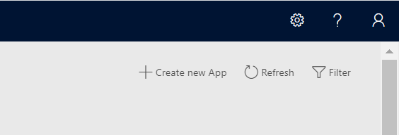

1. It will redirect to Powerapps Model driven app creation page

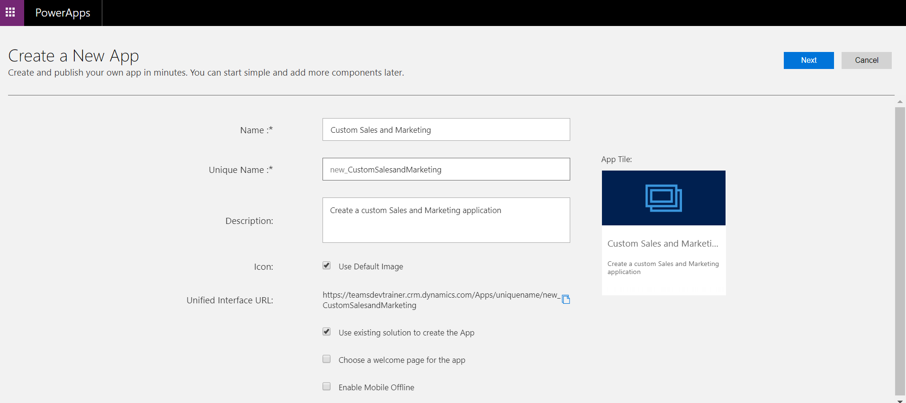

1. Give Name and description for the new app
2. Check “Use existing solution to create the App” to get the sales and marketing data source from the existing application.
3. Click Next button
4. Select Default Solution
5. Select ‘Sales Hub’ as Site map

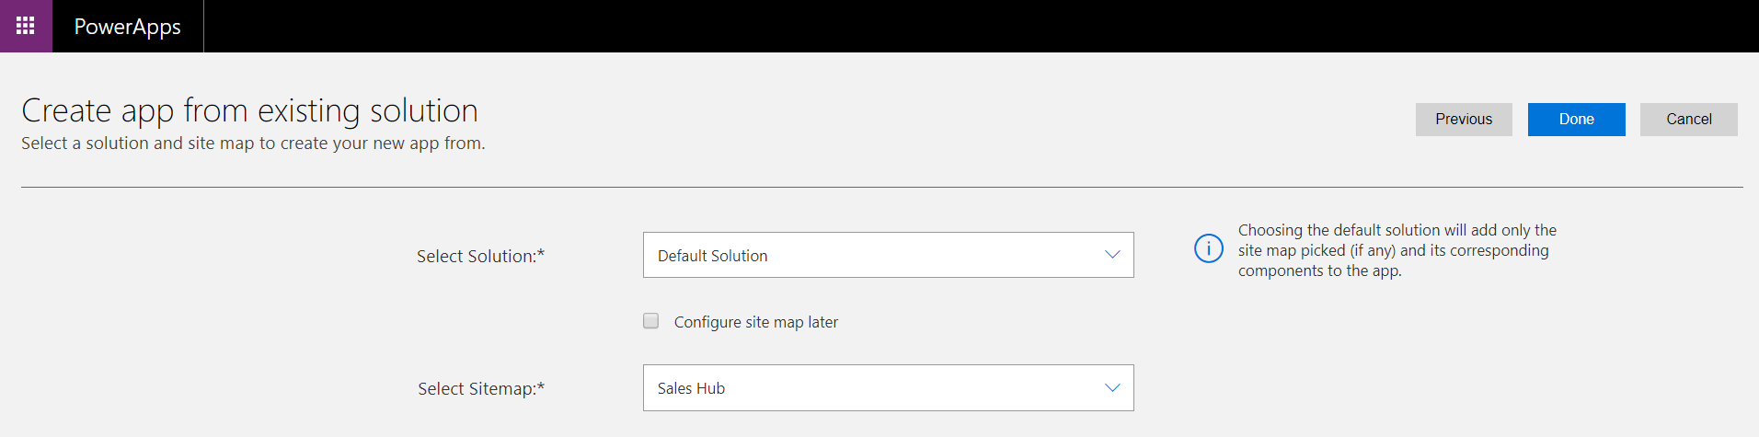

1. Click Done to create a custom app for Sales and Marketing
2. It will open the Power apps App designer and shows site map, Dashboards, Business Process and entities.

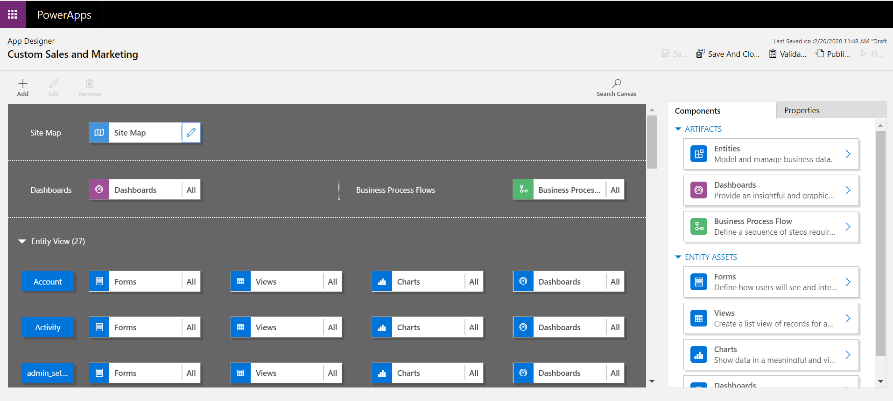

1. Edit the site map
2. Add/Modify the components

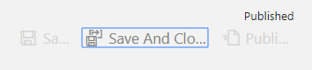

1. Save it
2. Publish it
3. Then go to entities
4. Create/remove/modify the forms, views, charts and dashboards
5. Then publish it
6. Play and test it, output looks below

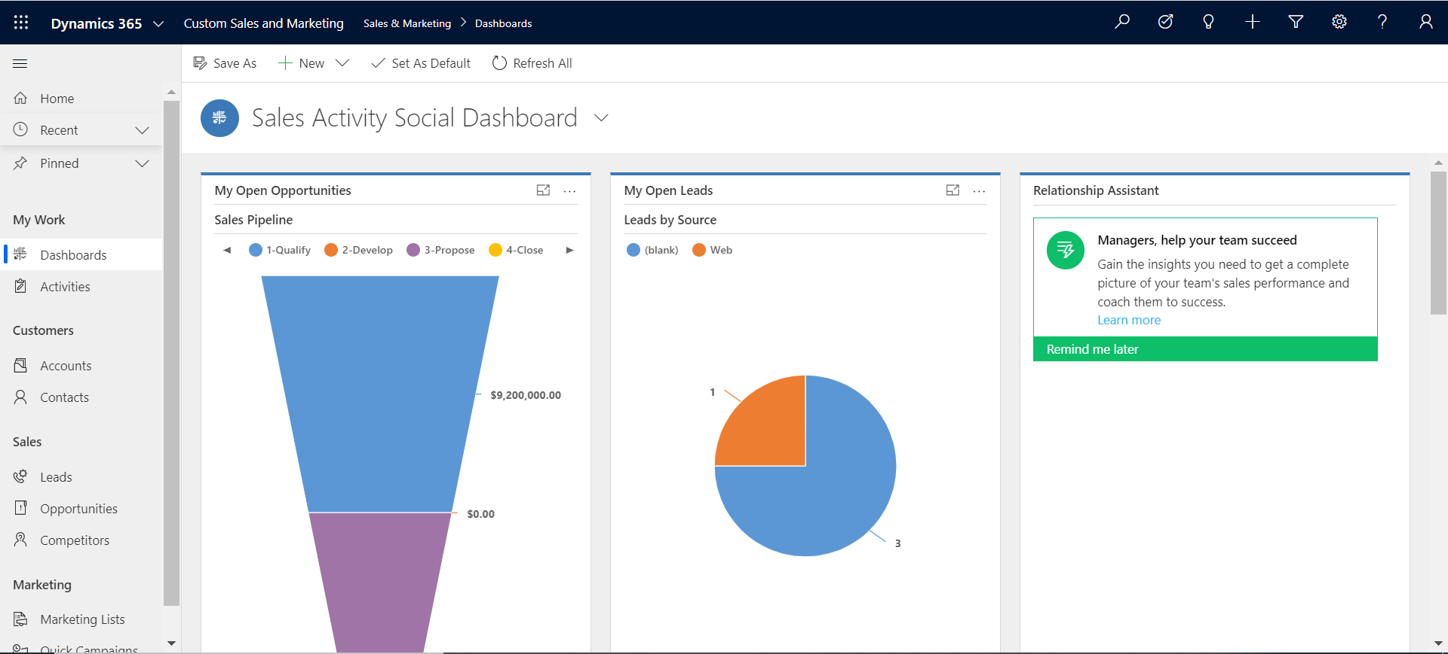

**Step 3: Embed Canvas App in Dynamics 365 Model driven App**

1. Go to PowerApps and Sign in
2. Select Solution menu in the left-hand side
3. Select Default Solution and open it

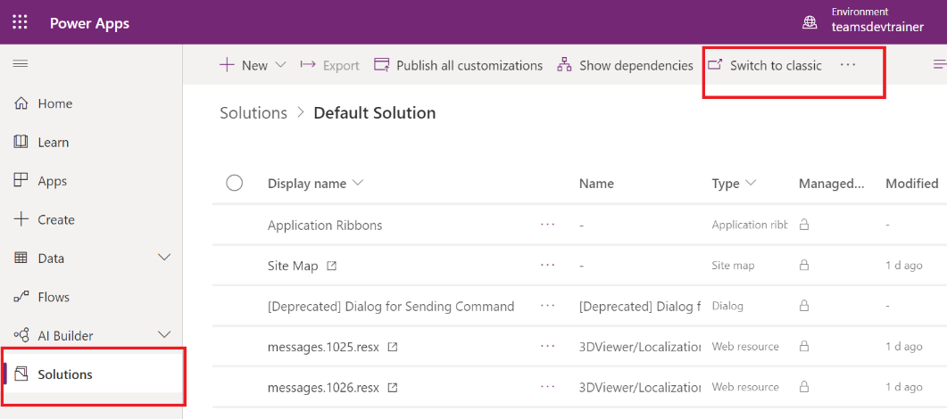

1. Click Switch to classic to edit the properties and layouts

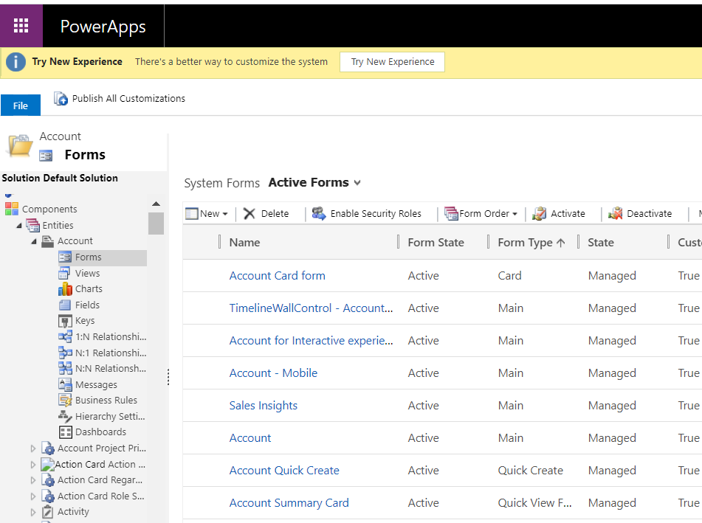

1. Select Entities 🡪 Account 🡪 Forms 🡪 Account (Main Form Type)
2. It will open the edit window

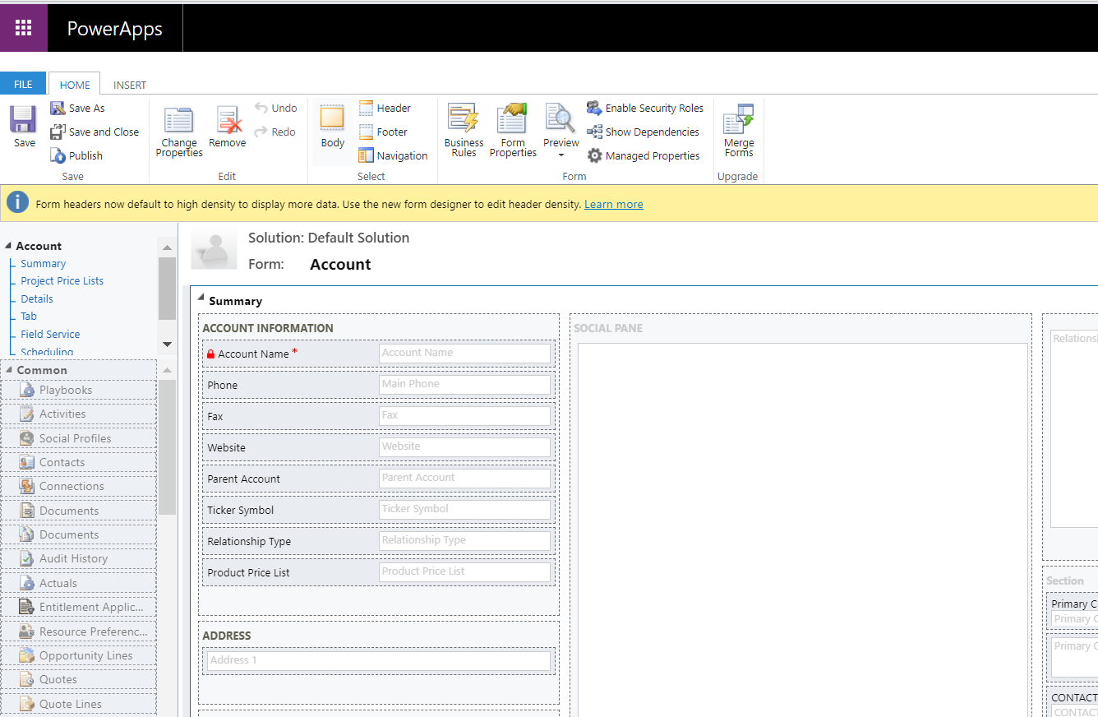

1. Go to Insert tab and Add new section for new tab to embed canvas app
2. Name the section as Custom Tab

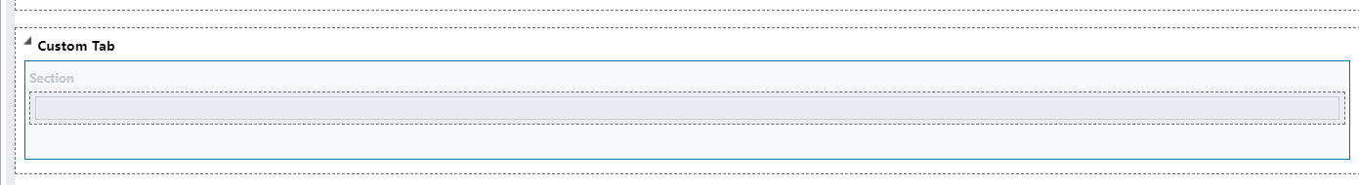

1. Add Account Name column
2. Double click and go to Field Properties
3. Go to Controls Tab

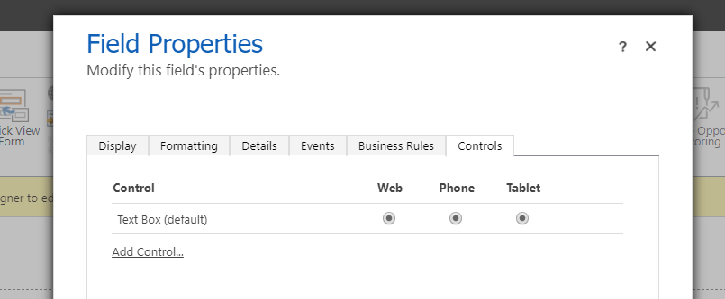

1. Click Add control and Select Canvas app

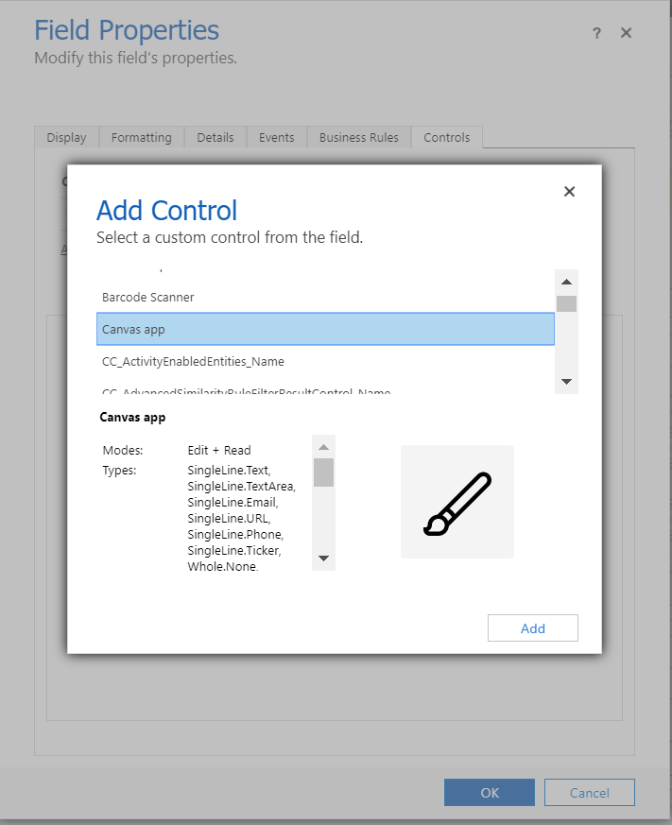

1. Click add to add canvas app to the control

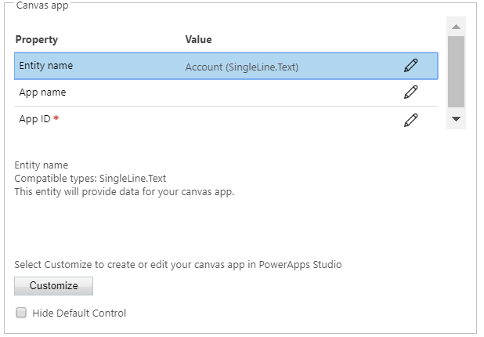

1. Click Customize button to add new canvas app
2. It will redirect and open power apps new window to create canvas app with account entity.

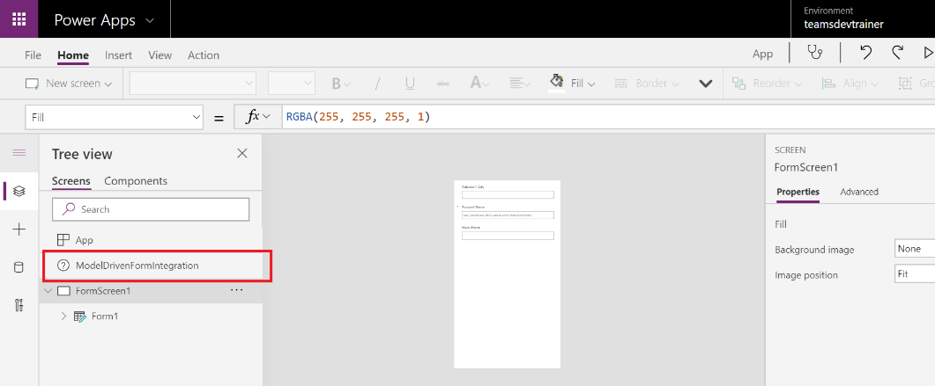

1. It will add ModelSDrivenFromIntegration link available in the screen section.
2. Save and Publish it

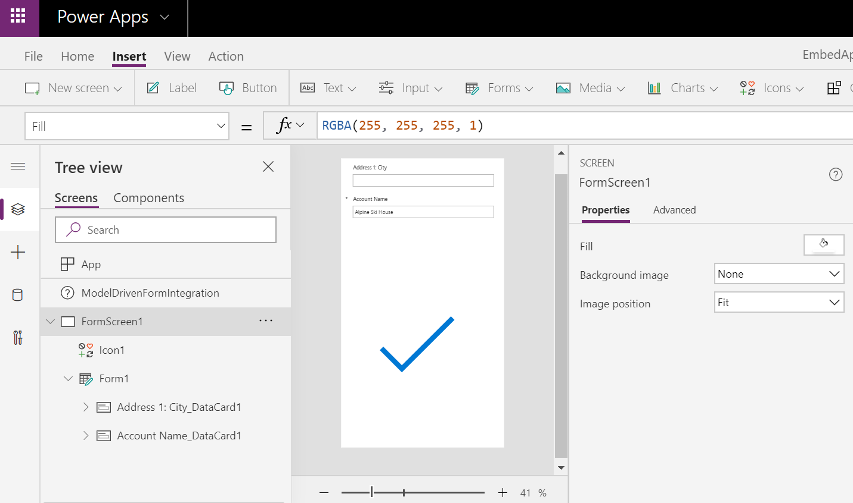

1. Now you can able to see the AppID and App Name in Field Properties window

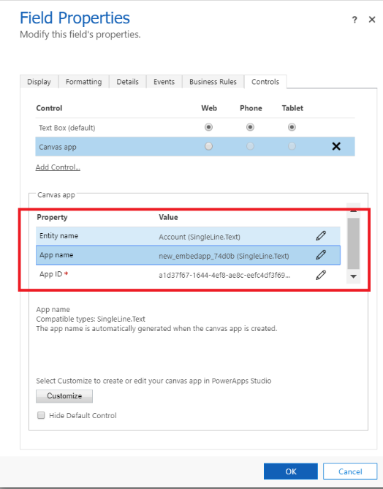

1. Save and Publish the account entity update.

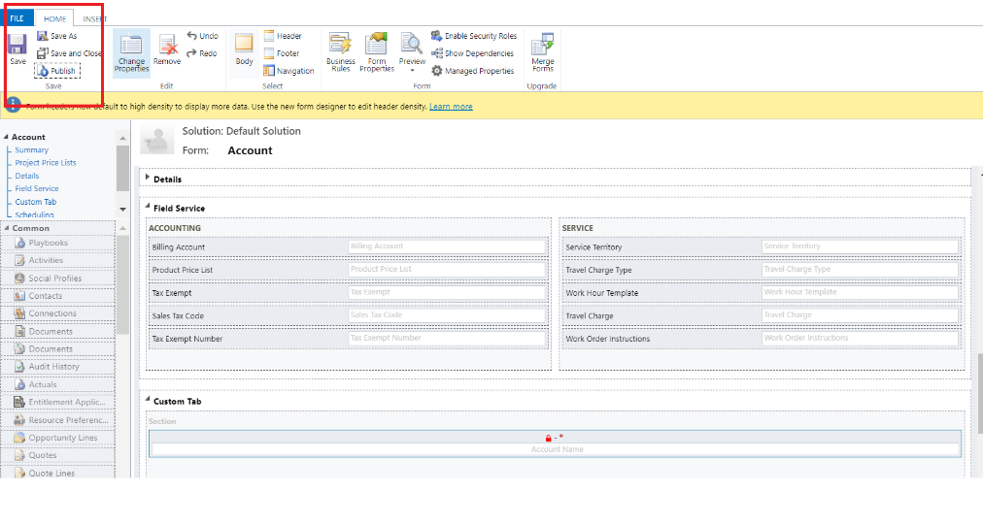

1. Test the canvas app
   1. Go to Dynamics 365 custom sales and marketing
   2. Open Account entity and click the account name to open the item
   3. Now you can able to see the new tab and inside the tab canvas app loaded.

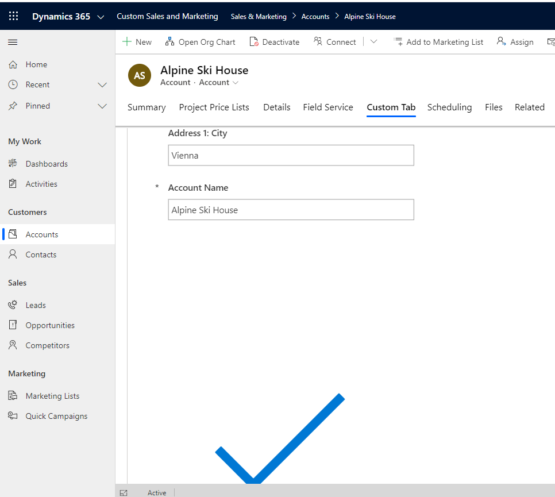

1. This way we can embed canvas app inside model driven app.